JAVA SAMPLE PROGRAMS

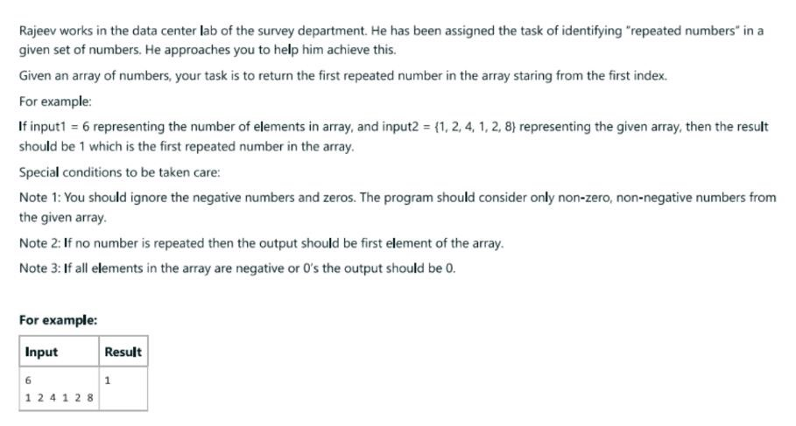

CODE:

import java.util.\*; class RepeatedNumber{

public static void main(String args[])

{

Scanner obj= new Scanner(System.in); int n=obj.nextInt(); //ARRAY SIZE

int[] a= new int[n]; boolean f=false; for (int i=0; i<n; i++)

{

a[i]=obj.nextInt();

}

for (int p=0;p<n;p++)

{ if(a[p]>0) { f=true;

}else{

System.out.print("0"); break;

} } if(f){ for (int j=0; j<n; j++){ for(int k=0; k<n; k++){ if(a[j]==a[k]) { System.out.print(a[j]); break; }else{ System.out.print(a[0]); break; } } break; }

}

}

}

OUTPUT:

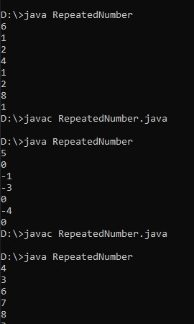

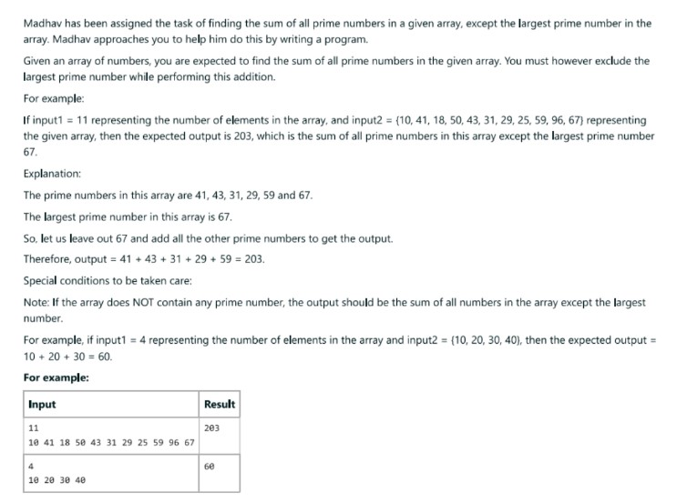

CODE:

import java.util.\*;

class SumPrime {

public static void main(String[] args) { Scanner sc = new Scanner(System.in);

int n = sc.nextInt(); int[] e = new int[n]; int sumOfPrimes = 0;

int largestPrime = 0; // Track the largest prime encountered

for (int i = 0; i < n; i++) { e[i] = sc.nextInt(); if (isPrime(e[i])) { sumOfPrimes += e[i];

if (e[i] > largestPrime) { // Update largestPrime if needed largestPrime = e[i];

}

}

}

System.out.println(sumOfPrimes - largestPrime); // Subtract the largest prime

}

static boolean isPrime(int num) { if (num <= 1) { return false;

} for (int i = 2; i \* i <= num; i++) { if (num % i == 0) { return false;

} } return true;

} }

OUTPUT:

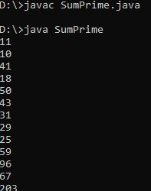

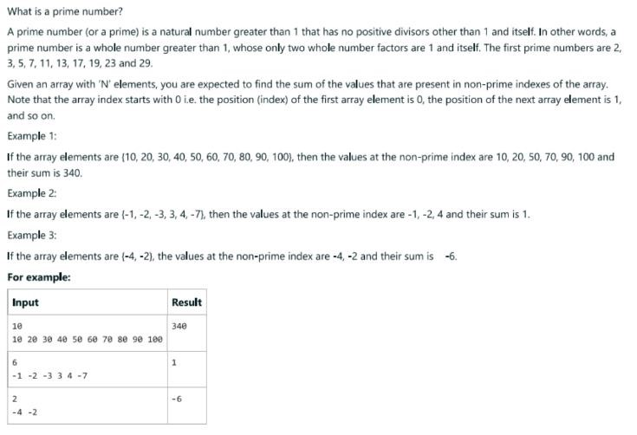

CODE:

import java.util.\*;

class SumIndexPrime {

public static void main(String[] args) { Scanner sc = new Scanner(System.in);

int n = sc.nextInt(); int[] e = new int[n]; int sum = 0;

for (int i = 0; i < n; i++) { e[i] = sc.nextInt(); if (!isPrime(i)) {

sum += e[i];

}

}

System.out.println(sum);

}

static boolean isPrime(int num) { if (num <= 1) { return false;

}

for (int i = 2; i \* i <= num; i++) { if (num % i == 0) { return false;

} } return true;

} }

OUTPUT:

